5.Once there click on change adapter settings

1.Push the windows key to open the menu

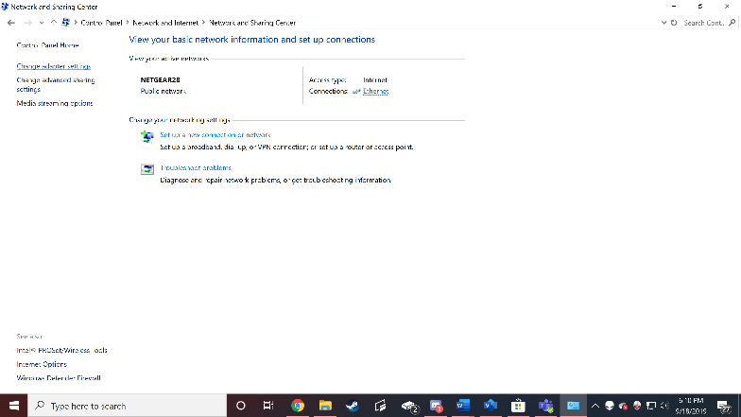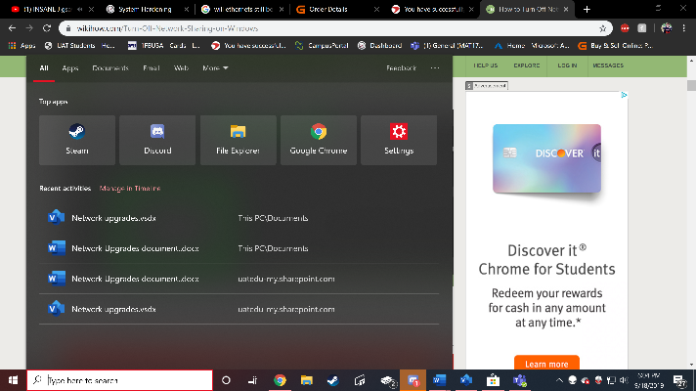

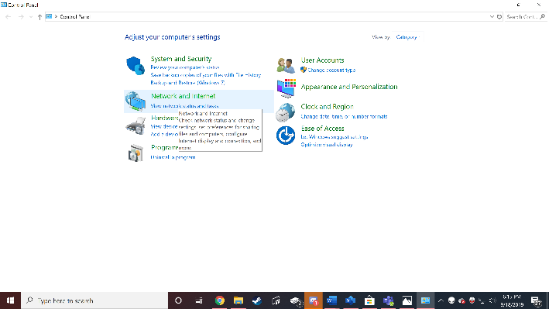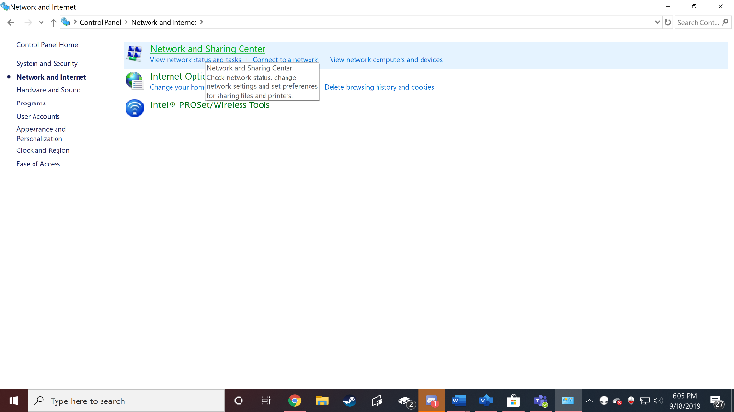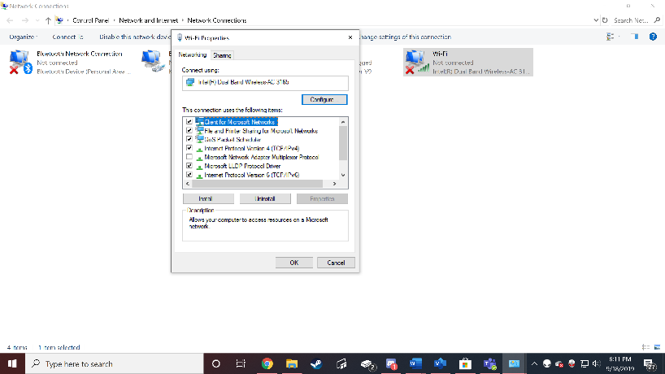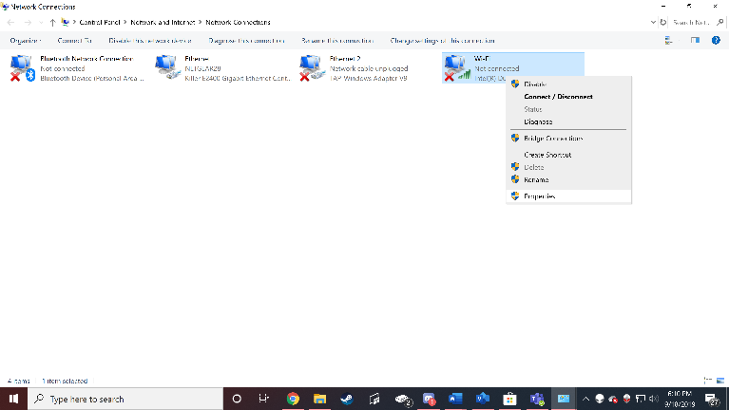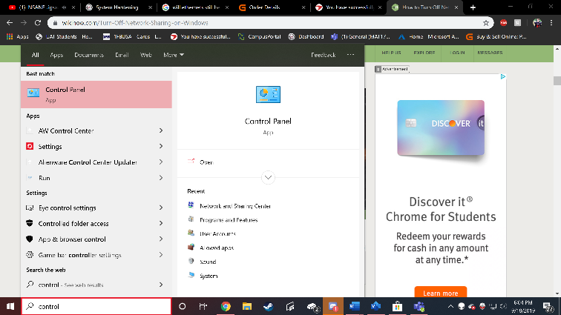

3.open control panel and then click network and internet

4. open control panel and click on network and sharing

7. Once in properties, click on the sharing tab.

6. Go to the network that you’re and right click then click Properties.

2.Type control panel so you can open it.

10. once you hit ok, your information will only be available to you on the network

8. If the first box is clicked unclick it.

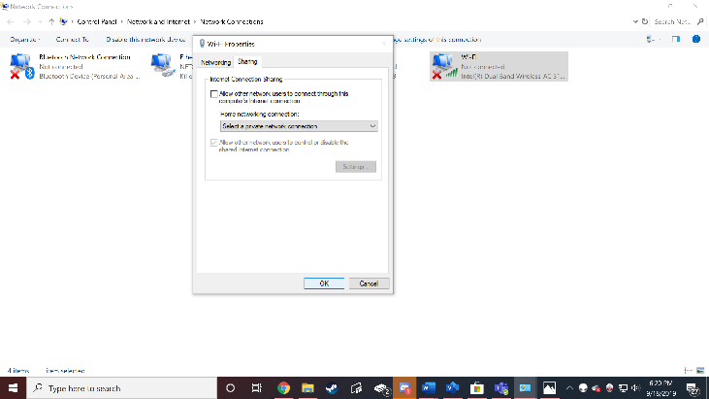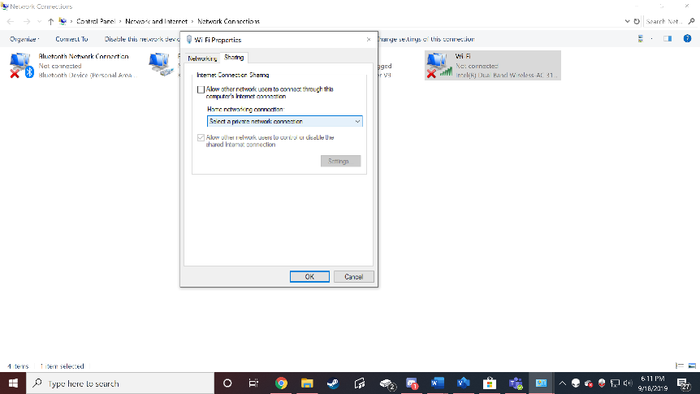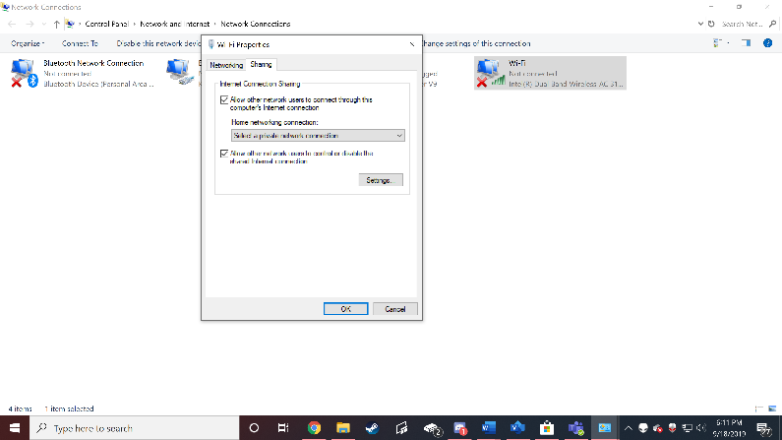

9.This doesn’t allow your info being shared with others on the network.