My AWS Was not working, but I have the screenshots from class.
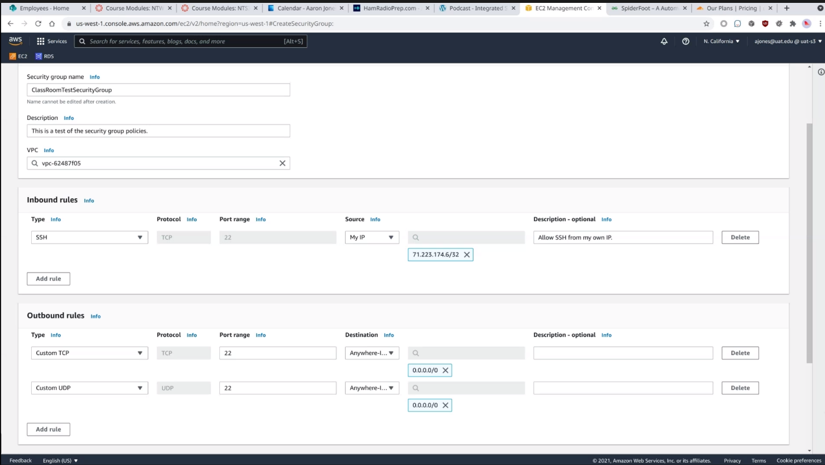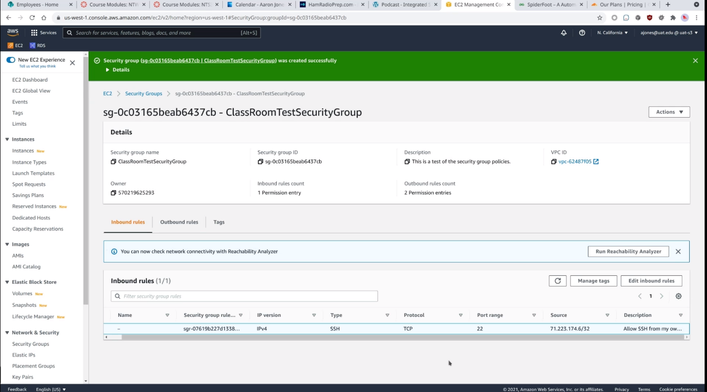
While making this, you need to make sure that the other servers and or computers you have can SSH into it. This ensure that updates can be applied throughout the whole system and that you can connect with them if the need help with certain software’s and such. You also must make sure that you only allow certain IP’s to get to their server. Making sure that no connections are made without your permission and such.

